Student Learning Objectives

* Timer control
* Tool Tip Control
* Picture Box Control
* Menu Controls
  + Using the **OpenFileDialog**
  + Using the Copy, Paste and Cut Clip Board
* Random Class

**There are 11 print screens/code copy each worth 9.09%**

Working with the timer control

**Project #1**

**Design**

**Code**

**#1 print screen the output with code below here**

Public Class Controls

Private Sub Button1_Click(sender As Object, e As EventArgs) Handles Button1.Click

TextBox1.Text = "0"

Timer1.Enabled = True

End Sub

Private Sub Button2_Click(sender As Object, e As EventArgs) Handles Button2.Click

Timer1.Enabled = False

End Sub

Private Sub Timer1_Tick(sender As Object, e As EventArgs) Handles Timer1.Tick

TextBox1.Text = (CDbl(TextBox1.Text) + 0.1).ToString("N1")

End Sub

Working with the Tool Tip control

**Project #2**

The Visual Basic IDE uses tooltips to identify buttons on the Toolbar and icons in the Toolbox. When we hover the mouse over one of these items, a small rectangular box appears after second and remains visible for 5 seconds. The ToolTip control allows us to create tooltips for the controls in our programs.

**Design**

**Code**

To use the tool tip on the 1st text box



Click on the tooltip control and change the isBalloon = true, which will give us a balloon effect



**#2 print screen the output with code below here  
**

Private Sub Button3_Click(sender As Object, e As EventArgs) Handles Button3.Click

Dim taxRate As Decimal = CDec(TextBox2.Text) / 100

Dim price As Decimal = CDec(TextBox3.Text)

Dim totalCost As Decimal = price + (taxRate * price)

MessageBox.Show("Price " & totalCost.ToString("C"))

End Sub

Working with the Menu control

**Project #3**

**Design**

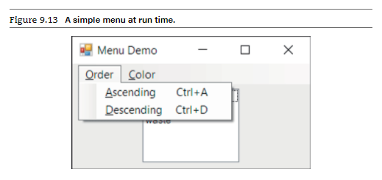

**Code**

On the load event add the following to the list box

Double click on the Ascending Menu and type in the following code

Double click on the Descending Menu and type in the following code

Create a menu Color as shown below for Red, Blue, Yellow, and White

Red Sub Menu Code



Blue Sub Menu Code

Yellow Sub Menu Code

White Sub Menu Code

Create another sub menu and name it open as shown below under the Order menu

Double click on the Open Sub menu and type in the following code, the code will find all .bmp files when it is pressed.

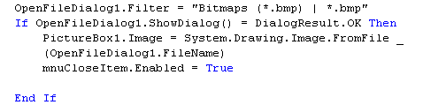

**#3 print screen the output below here**

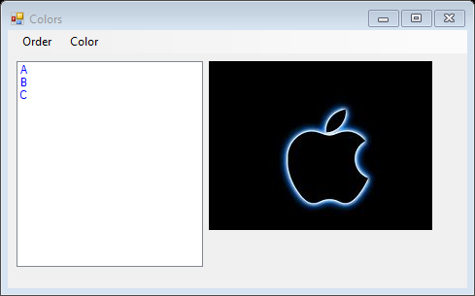

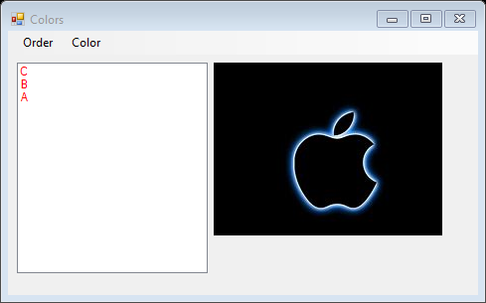

**#4 copy and paste the code below here**

Public Class Colors

Private Sub RedToolStripMenuItem_Click(sender As Object, e As EventArgs) Handles RedToolStripMenuItem.Click

ListBox1.ForeColor = Color.Red

End Sub

Private Sub BlueToolStripMenuItem_Click(sender As Object, e As EventArgs) Handles BlueToolStripMenuItem.Click

ListBox1.ForeColor = Color.Blue

End Sub

Private Sub YellowToolStripMenuItem_Click(sender As Object, e As EventArgs) Handles YellowToolStripMenuItem.Click

ListBox1.ForeColor = Color.Yellow

YellowToolStripMenuItem.Checked = False

WhiteToolStripMenuItem.Checked = True

End Sub

Private Sub WhiteToolStripMenuItem_Click(sender As Object, e As EventArgs) Handles WhiteToolStripMenuItem.Click

ListBox1.ForeColor = Color.White

YellowToolStripMenuItem.Checked = False

WhiteToolStripMenuItem.Checked = True

End Sub

Private Sub OpenToolStripMenuItem_Click(sender As Object, e As EventArgs) Handles OpenToolStripMenuItem.Click

OpenFileDialog1.Filter = "Bitmaps (*.bmp) | *.bmp"

If OpenFileDialog1.ShowDialog() = DialogResult.OK Then

PictureBox1.Image = System.Drawing.Image.FromFile(OpenFileDialog1.FileName)

End If

End Sub

Private Sub Colors_Load(sender As Object, e As EventArgs) Handles MyBase.Load

ListBox1.Items.Add("C")

ListBox1.Items.Add("B")

ListBox1.Items.Add("A")

End Sub

Private Sub AscendingToolStripMenuItem_Click(sender As Object, e As EventArgs) Handles AscendingToolStripMenuItem.Click

ListBox1.Sorted = True

End Sub

Private Sub DescendingToolStripMenuItem_Click(sender As Object, e As EventArgs) Handles DescendingToolStripMenuItem.Click

Dim temp(2) As String

ListBox1.Sorted = True

For i As Integer = 0 To 2

temp(i) = CStr(ListBox1.Items(i))

Next

ListBox1.Sorted = False

ListBox1.Items.Clear()

For i As Integer = 2 To 0 Step -1

ListBox1.Items.Add(temp(i))

Next

End Sub

End Class

**Project #4**

**Code**

This example copys text to a clip board

Note: Complete the code for the Paste and Cut sub menus.

**#5 print screen the output with code below here**

Public Class Clipboard

Private Sub CopyToolStripMenuItem_Click(sender As Object, e As EventArgs) Handles CopyToolStripMenuItem.Click

My.Computer.Clipboard.SetText(TextBox1.Text)

MessageBox.Show("Text copied to clipboard")

End Sub

Private Sub PasteToolStripMenuItem_Click(sender As Object, e As EventArgs) Handles PasteToolStripMenuItem.Click

TextBox1.Text = My.Computer.Clipboard.GetText

MessageBox.Show("Text Pasted")

End Sub

Private Sub CuTToolStripMenuItem_Click(sender As Object, e As EventArgs) Handles CuTToolStripMenuItem.Click

My.Computer.Clipboard.SetText(TextBox1.Text)

TextBox1.Text = ""

MessageBox.Show("Text Cut")

End Sub

End Class

**Project #5**

**Random Class**

**Code**

Add a Button control labeled as **Display Contestants** and a List Box for the output. Here we are shuffling string names

**#6 print screen the output below here**

**#7 copy and paste the code below here**

Private Sub Button2_Click(sender As Object, e As EventArgs) Handles Button2.Click

Dim r As New Random

Dim contestants() As String = {"Mary", "Pat", "Linda", "Barbara", "Maria"}

Dim number As Integer, temp As String

For i As Integer = 0 To 4

number = r.Next(i, 5)

temp = contestants(i)

contestants(i) = contestants(number)

contestants(number) = temp

Next

ListBox1.Items.Clear()

For i As Integer = 0 To 4

ListBox1.Items.Add(contestants(i))

Next

End Sub

End Class

Powerball code

Public Class RandomClass

Private Sub Button1_Click(sender As Object, e As EventArgs) Handles Button1.Click

TextBox1.Text = False

TextBox2.Text = False

TextBox1.BackColor = Color.Blue

TextBox1.ForeColor = Color.Red

TextBox2.BackColor = Color.Black

TextBox2.ForeColor = Color.Red

TextBox1.Text = Math.Floor(Rnd() * 69) & " " & Math.Round(Rnd() * 69) & " " & Math.Round(Rnd() * 69) & " " & Math.Round(Rnd() * 69) & " " & Math.Round(Rnd() * 69)

TextBox2.Text = Math.Floor(Rnd() * 29)

End Sub

**Project #6**

Note: ***Create*** a members.txt file with four members

**Note: Complete the Offices App program.**

**#8 Print screen the output below here**

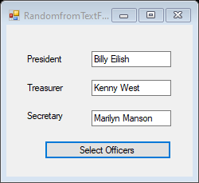

**#9 Copy and paste your code below here**

Public Class RandomfromTextFile

Private Sub Button1_Click(sender As Object, e As EventArgs) Handles Button1.Click

Dim officers() As String = IO.File.ReadAllLines("C:\Users\angel\Desktop\Project6.txt")

Dim number As Integer, temp As String

Dim r As New Random

For i As Integer = 0 To 2

number = r.Next(i, 3)

temp = officers(i)

officers(i) = officers(number)

officers(number) = temp

TextBox1.Text = officers(i)

Next

For i As Integer = 0 To 2

If TextBox3.Text.Length = TextBox1.Text.Length Then

number = r.Next(i, 3)

temp = officers(i)

officers(i) = officers(number)

officers(number) = temp

TextBox2.Text = officers(i)

End If

Next

For i As Integer = 0 To 2

If TextBox3.Text.Length = TextBox2.Text.Length Or TextBox1.Text.Length Then

number = r.Next(i, 3)

temp = officers(i)

officers(i) = officers(number)

officers(number) = temp

TextBox3.Text = officers(i)

End If

Next

End Sub

End Class

**#10 Open your note pad with the members listed and print screen it below here**

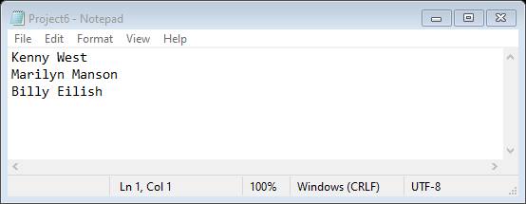

**Project #7**

**Tool Tip**

**Note: Complete the tool tip assistance program, add only the tool tip on the Name text box.**

**#11 print screen the output with code below here**Graphical user interface, application

Description automatically generated

**Submit this document to Module 10 Class Exercise**